Name: **ZOHAIB HASSAN SOOMRO**

RollNo#: **19SW42**

Subject: **DBS**



**JOIN Examples:**

1. **CROSS JOIN:**

SELECT empno,ename,dname,loc from emp2 cross join dept2;

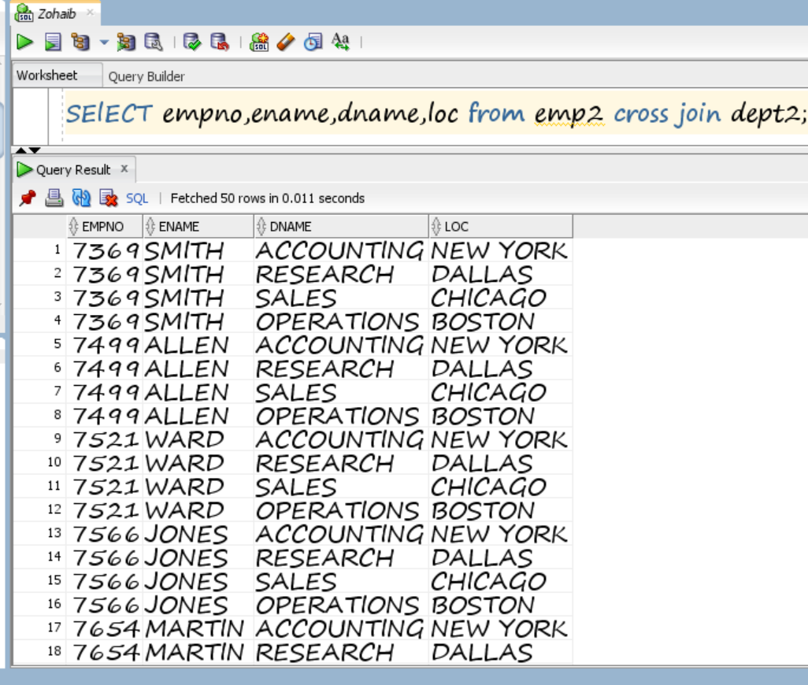

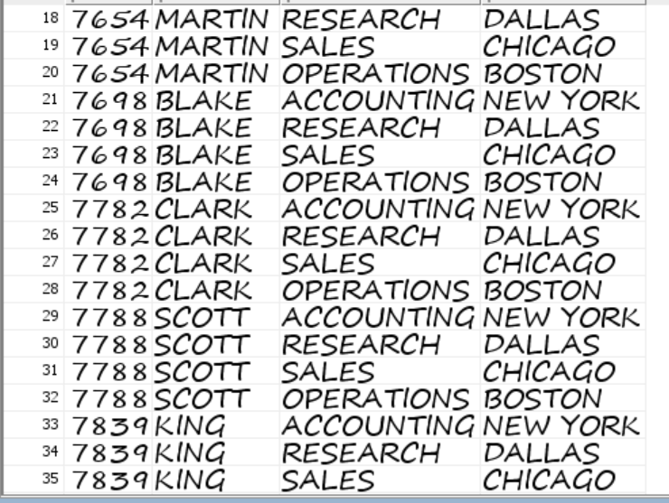

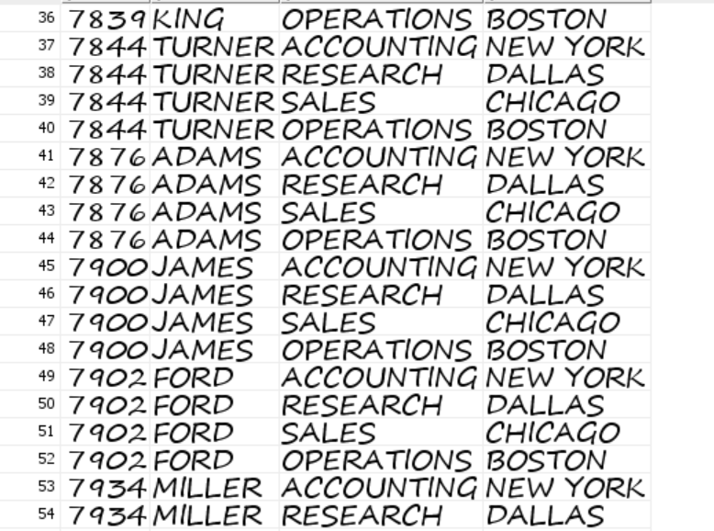



1. **CARTESIAN JOIN:**

SELECT empno,ename,dname,loc from emp2 , dept2;

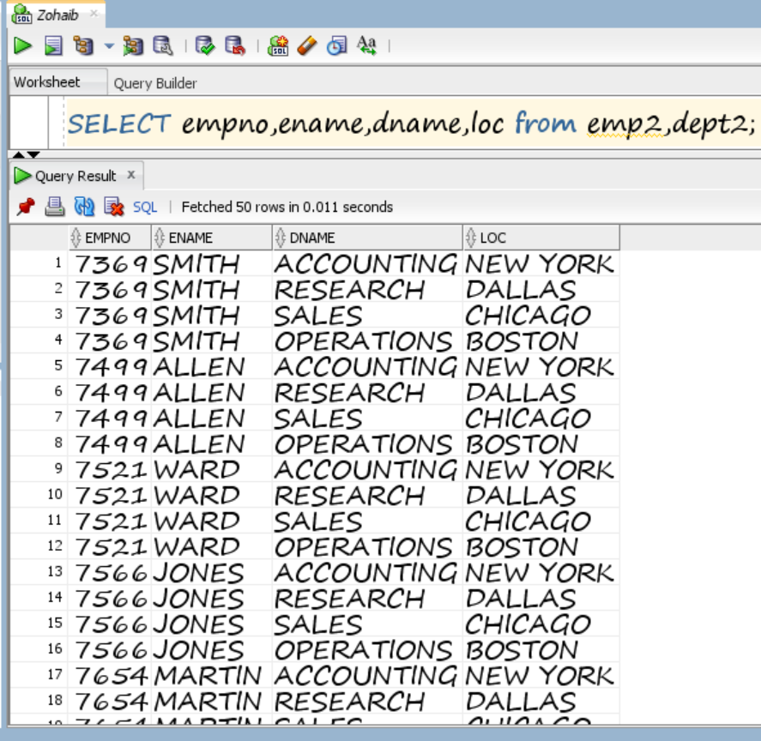







1. **EQUI JOIN(with table aliases):**

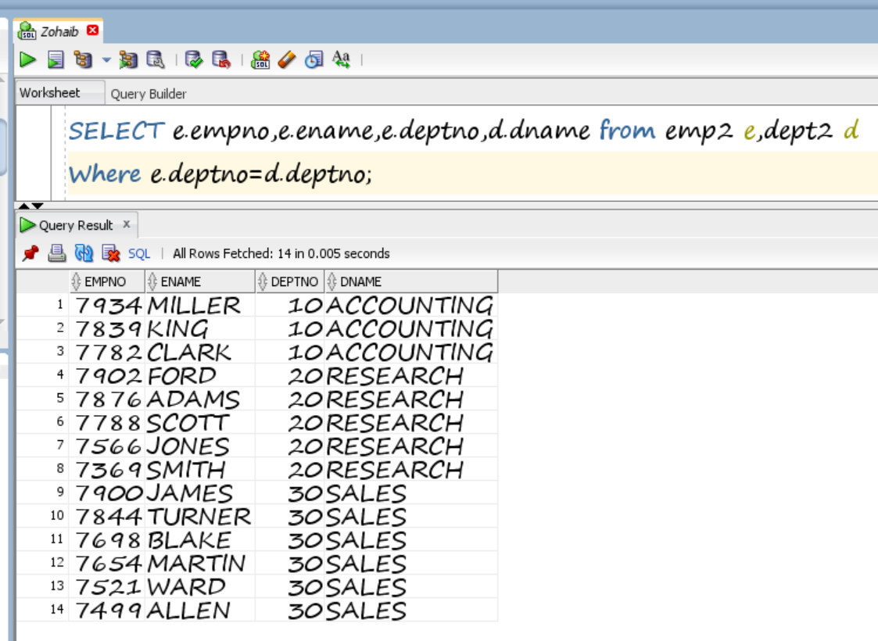

1. **EQUI JOIN(without table aliases):**

